Poster Template
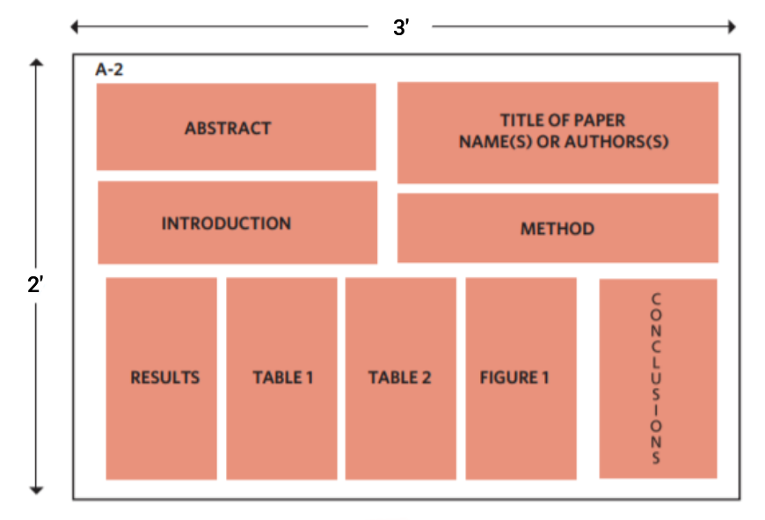
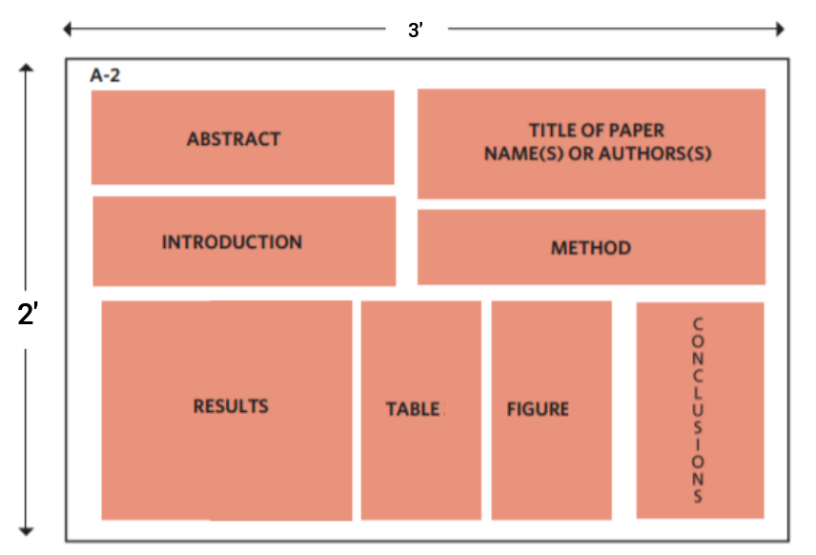
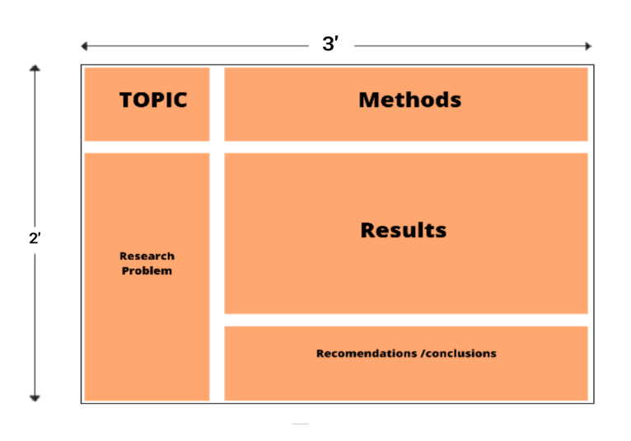
The authors may choose any of the above templates based on their research work and results. The poster may be flex/canvas printed and the organizers shall provide the space for the display.

